Joshua Williamson
CS-330
January 16th, 2025

Module 2-3
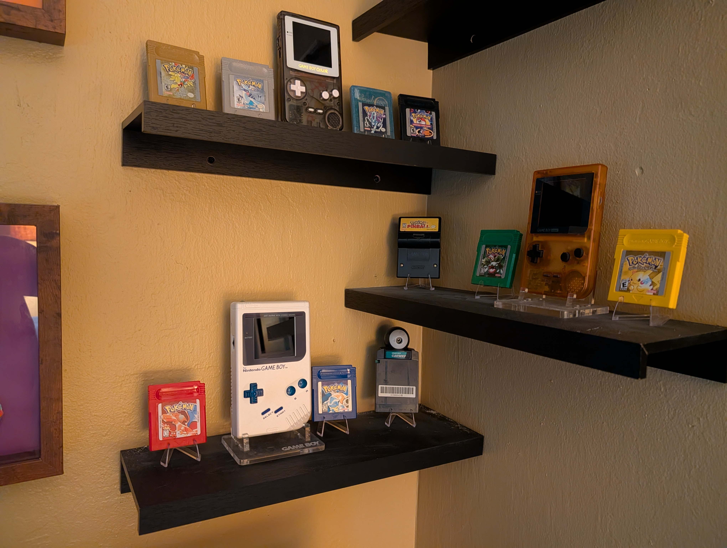
The 2D image selected for this project is a photograph that I took of a retro gaming display mounted on wall shelves. The image shows multiple Nintendo Game Boy handheld systems, Pokémon game cartridges, and floating shelves arranged in a corner of a room. The scene contains distinct objects and provides enough variety in shape and structure to translate into a 3D environment.

Breakdown of Basic 3D Shapes

Game Boy Handhelds
- Box: Main body of the console
- Plane: Screen surface
- Cylinder: Buttons components
- Boxes: Directional pad components arranged in a cross like shape.
- Torus: Rounded speaker grill or button outlines

Game Cartridges
- Box: Cartridge body
- Prism: Slightly angled bottom edge of the cartridge casing

Game Boy Camera Cartridge
- Box: Cartridge body
- Prism: Slightly angled bottom edge of the cartridge casing
- Sphere: For camera eye.

Floating Shelves
- Box: Shelf body
- Plane: Wall-facing contact surface

Cartridge Display Stands
- Box: Back support on stand
- Plane: Cartridge resting surface

Ground and Wall Plane
A plane will be used to represent the wall surface behind the shelves. This plane grounds the entire scene spatially and provides a consistent background for lighting and texture application.
References
Nintendo. (n.d.). Game Boy product information.
https://www.nintendo.com/

